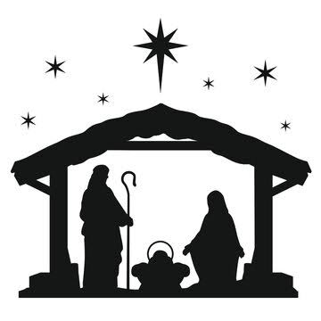
Christmas Mass Schedule

Christmas Eve Mass
Tuesday, December 24, 2024, 7:00pm at Saint Jude

Christmas Eve Mass
Tuesday, December 24, 2024, 9:00pm at Immaculate Conception

Christmas Day Mass
Wednesday, December 25, 2024, 10:00am at Saint Jude

