**Youth Group Activity**

**Sunday, April 27th**

12:30 to 3:00 St. Jude’s Social Hall

**Game Day!!!**

**Pizza, Snack, lemonade/tea, and fun.**

All children in grades K-12 are welcome.

**St. Jude, Immaculate Conception, and homeschool.**



[This Photo](https://freepngimg.com/png/54676-ice-water-free-hq-image) by Unknown Author is licensed under [CC BY-NC](https://creativecommons.org/licenses/by-nc/3.0/)



[This Photo](https://courses.lumenlearning.com/wmopen-psychology/chapter/positive-psychology/) by Unknown Author is licensed under [CC BY](https://creativecommons.org/licenses/by/3.0/)

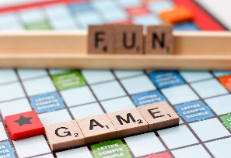

[This Photo](https://foto.wuestenigel.com/close-up-of-scrabble-board-game-with-words-game-and-fun/) by Unknown Author is licensed under [CC BY](https://creativecommons.org/licenses/by/3.0/)

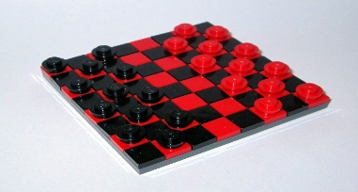

[This Photo](https://www.flickr.com/photos/spookyamd/6333318597) by Unknown Author is licensed under [CC BY](https://creativecommons.org/licenses/by/3.0/)