**COUNCIL 11262 OFFICERS**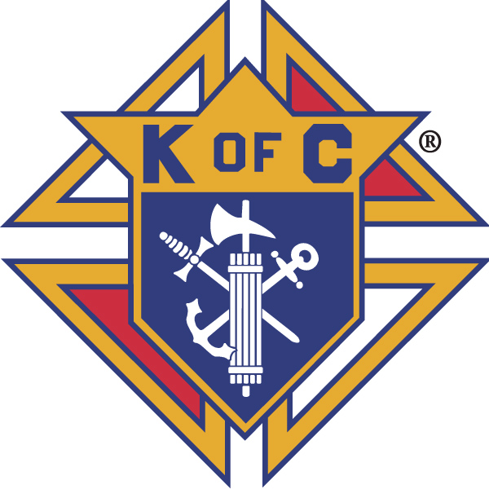

**CHAPLAIN**

Fr. Peter Calixtus (Cal)

**GRAND KNIGHT**

Mike Conlon

**DEPUTY GRAND KNIGHT**

Ken Lazzaro

**FINANCIAL SECRETARY**

Brian Johnson

**LECTURER (R)**

Scott Jack

**CHANCELLOR**

Rick Ross

**RECORDER**

Martin Ried

**TREASURER**

Bill Fleser

**ADVOCATE**

Danny O’Connell

**WARDEN**

Matt Miller

**INSIDE GUARD**

Joe DiPietro

**OUTSIDE GUARD**

Denny Bridge

**TRUSTEES**:

3 Year – Phil Trayer

2 Year -Scott Jensen

1 Year – Ron Brassard

**Monthly Newsletter**

* **Grand Knight’s Message**
* **Knight of the Month**
* **Family of the Month**
* **Financial Secretary Report**
* **4th Degree Report**
* **Culture of Life**
* **Prayer List**

**Grand Knight’s Message**

* Brother Knights,
* I would like to take this opportunity to thank our PGK Phil Trayer and his
* dedicated team of officers for a successful and productive year that saw our
* Sacred Heart Council not only grow in numbers but grow much closer
* together as one strong family.
* Thank you all for giving me the opportunity to serve as your new Grand Knight
* and thanks to our new team of officers who haveagreed to step up and serve.
* Rest assured we will apply our principals of Charity, Unity, Fraternity and
* Patriotism in both our team generated decisions and actions.
* As we embark on another fraternal year, we plan to display a much stronger
* focus on LOCAL, as it relates both donations towards financial aid and active
* involvement in the community. Let us make sure “SACRED HEART COUNCIL
* 11262” makes a difference in Louisa County!
* New things on the horizon that we will have further discussion at our next
* meeting. Meal Teams, Pancake Breakfast Teams, Annual Calendar, KOC
* Banner, KOC Bulletin Board, KOC 11262 Updated Website and more to come.
* Upcoming Events
* Our Officers Installation Ceremony will be on Saturday August 2, 2025
* following the 5pm Mass (approximately 6:15pm). The District Deputy and all
* newly elected officers will be in attendance. An invitation was sent to all
* Brother Knights and their wives. Pizza, Salad, Homemade Deserts, and drinks
* will be served following the ceremony.
* Our next Council Meeting (Wednesday August 6, 2025 6pm at Immaculate
* Conception) Dinner at 6pm, Rosary 6:45pm, Business Meeting 7pm.
* The proposed budget for 2025 – 2026 was handed out at our last meeting and
* will be up for discussion and vote at this meeting.
* The previous years semi annual audit is still under review. The results will be
* presented when completed.
* August 8, 2025, Funeral Mass for Brother Sir Knight Parker W Northrup Jr.
* at 10:am at St Jude Church.
* August 8, 2025, Fridays After 5 Fundraiser
* August 9, 2025 Spanish Mass 6:30pm
* The Feast Day for our founder Blessed Father McGivney is Wednesday
* August13,2025. Father Cal has agreed to celebrate the Feast Day on
* Thursday August 14, 2025, at 9:00am Mass at Immaculate Conception. All
* Brother Knights and wives are invited. It would be a profound way to show our
* appreciation for founding the organization that we belong to and support
* today. For those interested we say the Holy Rosary at 8:30am prior to the
* Mass.
* Flying Squirrels Game Night / Faith Night Thursday August 8,2025, 5:30 pm
* Brother Bill Fleser will review details
* Our next Officers Meeting will be on Wednesday August 27, 2025, at
* 5;30pm at St Jude.
* Brother Mike King had a Blood Drive with the Red Cross on July 9, 2025.
* Results will be reviewed at the meeting. The next Blood Drive is Wednesday
* September 10, 2025. Mike continues to knock it out of the park with these
* drives. Great Job Mike.
* Thanks For All You Guys Do.
* Mike Conlon GK

**UPCOMING EVENTS**

8/2 Officers Installation @

6:15 pm

8/6 Regular Meeting @ IC @

6:00 PM

8/8 Funeral Mass for Sir

Knight Parker Northrup

@ 10 am @ St. Jude

8/9 Spanish Mass @ St. Jude

6:30 PM

8/27 Officers Meeting @ St.

Jude @ 5:30 PM

|  |
| --- |
|  |
| **COUNCIL PROGRAM DIRECTORS**  General Program Director:  GK Mike Conlon  Vocations: Bill Fleser  Membership: PGK PFN Rick Dowsett  Recruitment: Matt Miller  Retention: Martin Reid  Faith: Scott Jack  Culture of Life: David Bruce  Council: Vacant  Community & Youth: Brian Johnson Family: PGK Phil Trayer  KOVAR: PGK Phil Trayer  KCIC: Jim Hogan  Council Blood Drives: Mike King  Triathlon: Scott Jensen  Benevolence Chairperson: Ron Brassard  Public Affairs: Vacant  Columbian Call Newsletter Publisher: Mark Richey |

**Knight of the Month**:

Sir Knight Parker Northrup Jr.

I am sure Sir Knight Parker Northrup Jr. is by far in a better place as we speak.

However, his time and work with us in this world as it relates to the Knights of

Columbus and St Jude Parish is unmatched. Prior to his declining health he

was an active Sir Knight in Assembly 2518 since 1995 (29 yrs), responsible in

key positions such as Deputy Grand Knight and Faithful Navigator. He was

also a highly active and involved member of our Sacred Heart Council 11262

holding many officer roles including Grand Knight. He has been a member of

the Knights of Columbus since 1956 with an accomplished 68 years of

service. WOW! I never had the pleasure of working with him as a Brother

Knight however I have heard many stories of the impact he had in both our

Council and the Assembly. He truly sets a high bar for all of us to reach in

terms of dedication, drive and leadership as seen through his involvement in

the Knights of Columbus.

Rest in Peace Brother Parker, until we meet again.

Mike Conlon GK

**Family of the Month**

Mike and Amy Schnetzler

Mike and Amy are active at Immaculate Conception attending both Sunday

and daily masses.

Mike handles all the Information Technology and Audio-Visual support

systems at IC which is key since approximately 30% of the parishioners view

the mass from a large screen in the hall. Working through the parish council

he recently installed a major upgrade on the system providing increased

clarity in both audio and visual. Mike is also a member of the choir. After mass

he helps in the kitchen keeping things organized and makes the best coffee in

Bumpass. He also is involved working with the Brunswick Stew Team.

Amy is involved in supporting just about all aspects at Immaculate

Conception. She is the lead sacristan, an Extraordinary Minister of Holy

Communion, the liturgy assistant, and member of the decoration team. As a

talented seamstress, Amy has put together multiple “Fair Linens” for the altar.

Her work is impeccable. She is also a member of the choir and is on the new

outreach social committee. Oh, I almost forgot, she is also an altar server and

a counter.

So, whenever I feel like plate is getting full, I just think of Amy and realize my

plate is only the size of a saucer.

Thanks Mike and Amy for all you do.

Mike Conlon GK

**Financial Secretary Report**

Here is the report for the month of June.

Receipts

$60 - dues collection

$1,103.25 intake from KOVAR

$497 - income from the Pancake Breakfast

$1050 - income from the Spring Triathlon

$17 - tips from our first Fridays After 5

Total : $2,727.25

Vouchers

Courage Lion Program  - $200

Father Bader Scholarship - $100

Global Wheelchair Mission - $500

Louisa County Emergency Fund - $1000

Louisa County Resource Council - $3,000

Restoration Ministries - $500

Dolly Parton Imagination Library - $1,000

KOVAR - $3,400 (matching for the year)

St. Jude Parish - $1,000 for utilities for both churches

VKCCI - $225 - donation by request of the DD

Dalton Allen - $500 - help with college

Mike Conlon - $500 - 2 grills for the fish fry

Rose Marie Ayres - $47.17 the rest of the money we owed her for the Dr. Hart presentation

John Cempre Council 6328 - $50 for tootsie rolls for KOVAR

Life Spring Pregnancy Center - $500

Total : $12,522.17

Brian Johnson, PGK

FS 11262

**4th Degree**

The 4th Degree Assembly had their Installation of Officers on July 17th.  SK Doug Mullinex is our Worthy Faithful Navigator for his 2nd year.

The Assembly conducted their annual audit and records show the assembly in good standards.

Our Faithful Pilot SK Patrick Edwards PGK Funeral was held on July 16th.  A Chalice Ceremony was conducted at his visitation.

The August Meeting location was changed to St Peter and Paul church on August 21st.  Meal is served at 6:30 and the assembly meeting starts around 7:30

Vivat Jesus

Ken Lazzaro

**BIRTHDAYS & ANNIVERSARIES**

**Birthday**

8/1 Josha Vrabel

8/2 William Kliner Jr.

8/2 Daniel Schoenster

8/10 Scott Jensen

8/13 DCennis Di Donna

8/15 Daniel Budi

8/17 Rev Paul Fitzpatrick

8/18 Lawrence Kavanagh

8/21 Donald Hurd

8/31 David Clune

**Anniversaries**

8/1 Gilbert & Joanne Barta

8/1 Patrick & Cathy O’Connell

8/4 William & Dee Kliner  
8/9 Parker & Mary Northrup

8/12 Edward & June Lucas

8/28 Harold & Lilliane Connor

8/30 Steven & Joanne Falkenthal

8/30 David & Kathy Zeiler

-------------------------------------------

***Editor’s Note:***  ***If I missed your birthday or anniversary, or the birthday of your spouse or minor child, please let me know so that I can update my records:******phone*** **(703) 217-0758 *or e-mail:* mrichey4444@gmail.com**

**SPIRITUAL ACTIVITIES**

**Culture of Life**

Please continue to support Pro Life in our local area.

Dave Bruce

**REQUEST FOR PRAYERS**

Dana Steele RIP

George Steele

Bob Falkenback

Roy Becks

Ron Hohenstein

Fran Verjenski

Imbachi Family

Our Seminarians

Celia Beach

Carrie Jack H&H

Donna Jack H&H

Carole Jack H &H

Judy Urban H&H

Dave Bruce

Phil Carr

Jessica Dowling H&H

Maxine Anderson H&H

Jeff Jefferson H&H

Vicki Oliver H&H

Glenda Riedl H&H

U.S. Armed Forces personnel and their families.

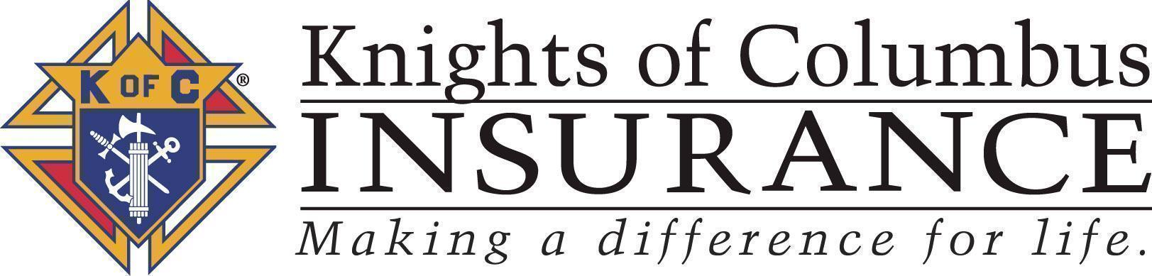



The *Columbian Call* is published by and for the membership of the Knights of Columbus, Sacred Hearts Council 11262. Opinions expressed are those of the individual author and do not necessarily reflect those of Sacred Hearts Council, the Grand Knight, the officers, the editor or the Knights of Columbus..



Are you planning a move? …down the street, across the lake or across the country? Complete a Form 100 with your new address and telephone number. Give (mail) the form to the council’s Financial Secretary, Brian Johnson. Also notify the newsletter editor, Mark Richey, to ensure you continue to receive your Columbian Call